**GUI MANUAL TEST PLAN**

1. **On running the app you would be asked to enter both the player’s name.**

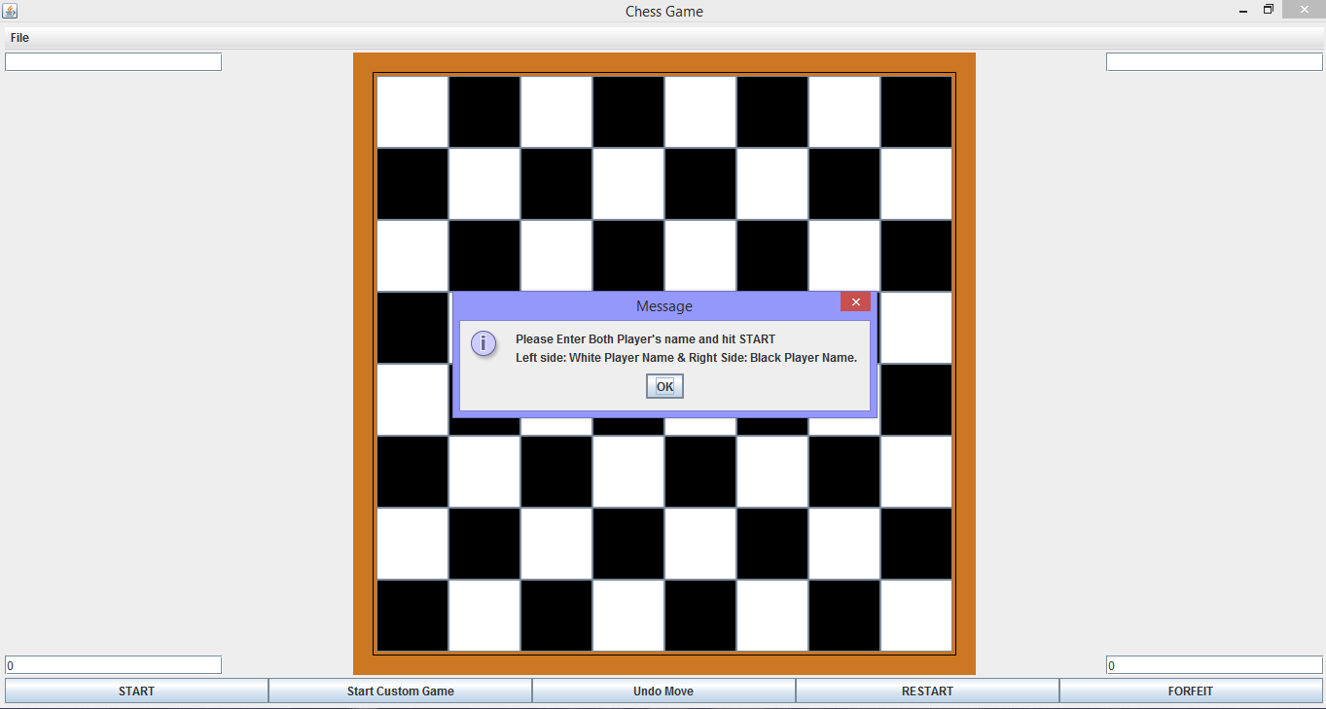

1. **After entering the player’s name you can start a normal game by pressing START.**

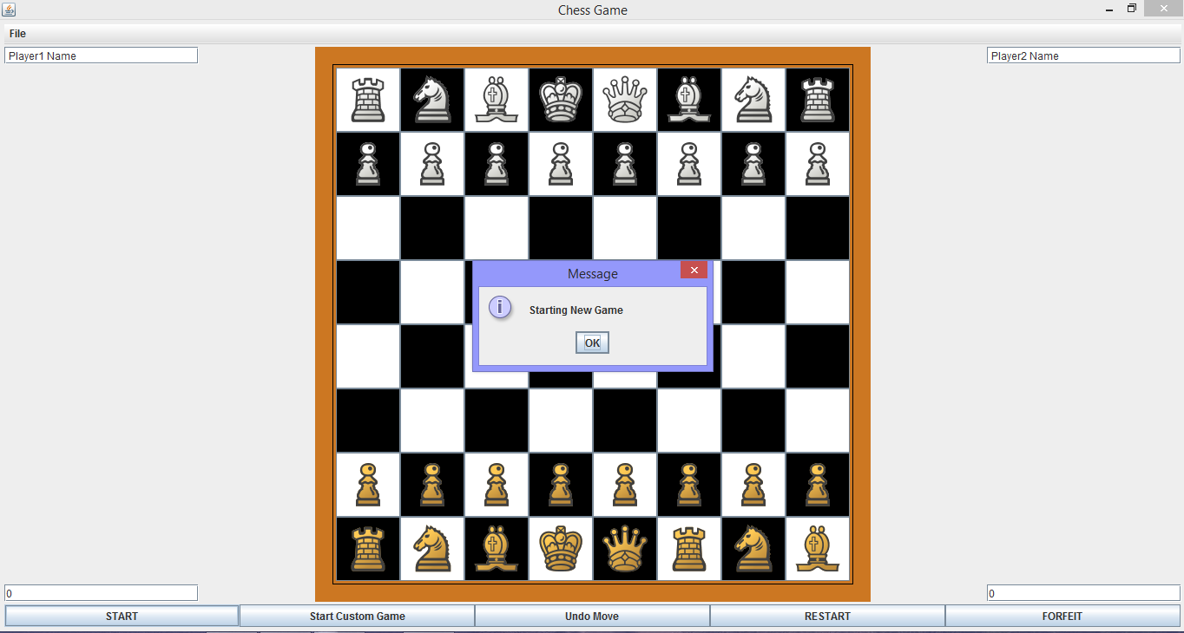

1. **You can also start a custom game and have fun with custom pieces like super pawn and knook.**

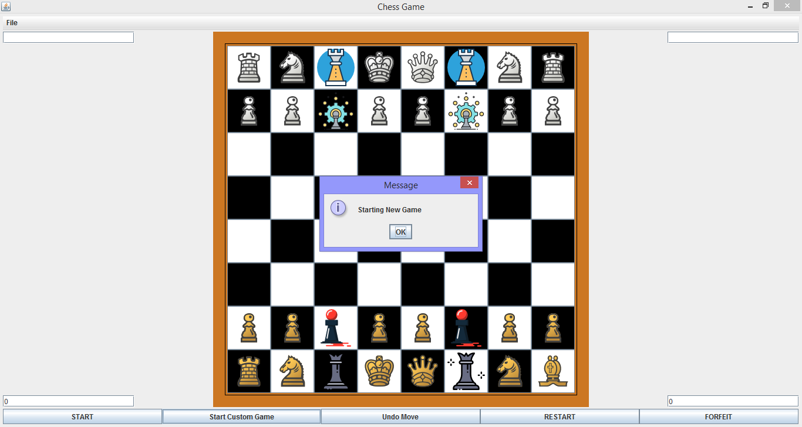

1. **The dialog box will ask the respective player to make a move.**

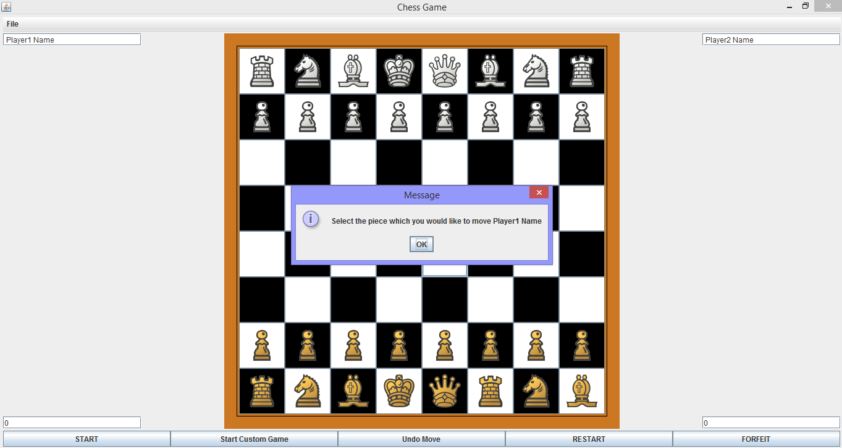

1. **On selecting a piece the possible moves your piece can take will highlight.**

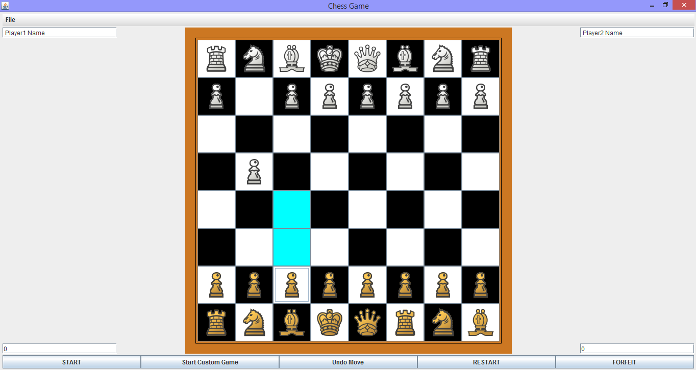

1. **You can undo one move before the other player has made his move.**

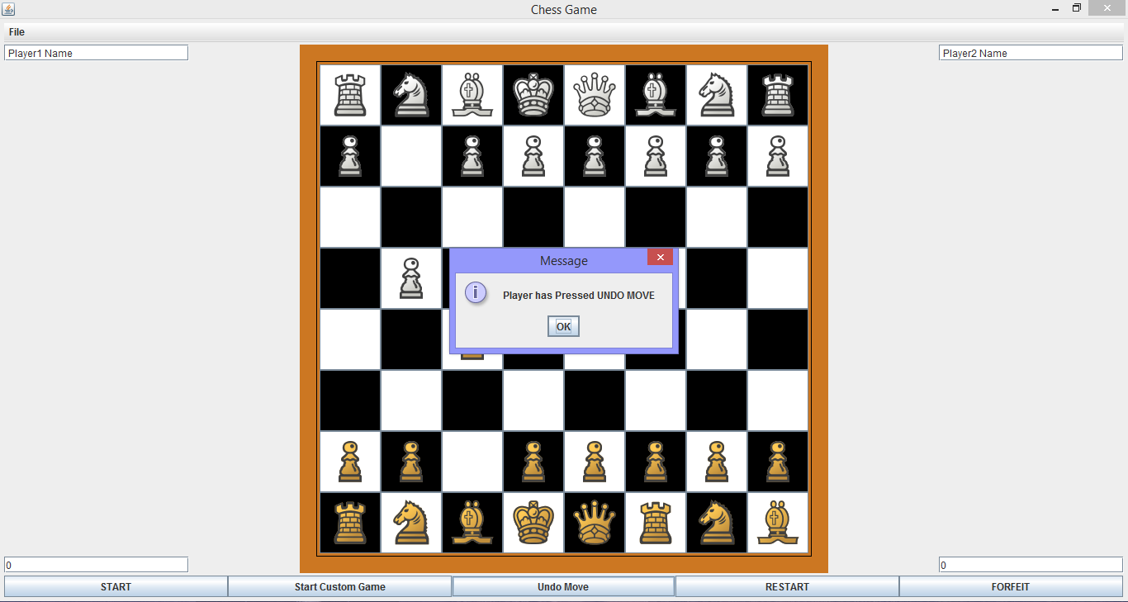

1. **On selecting a board square with no piece you will be prompted.**

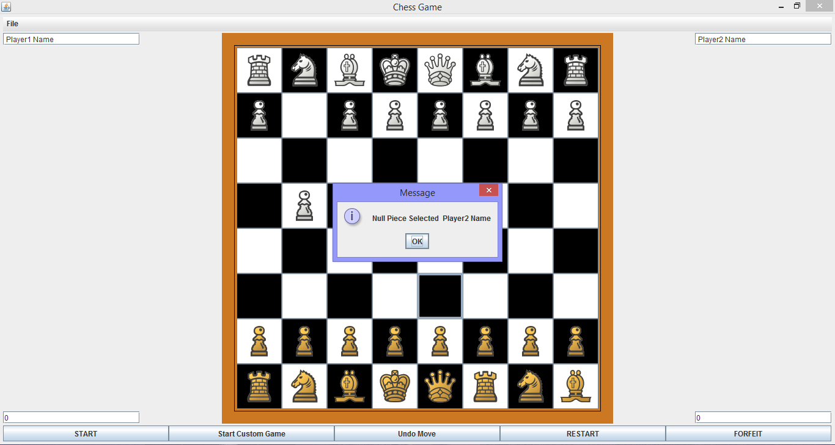

1. **You can forfeit the game by pressing the forfeit button.**

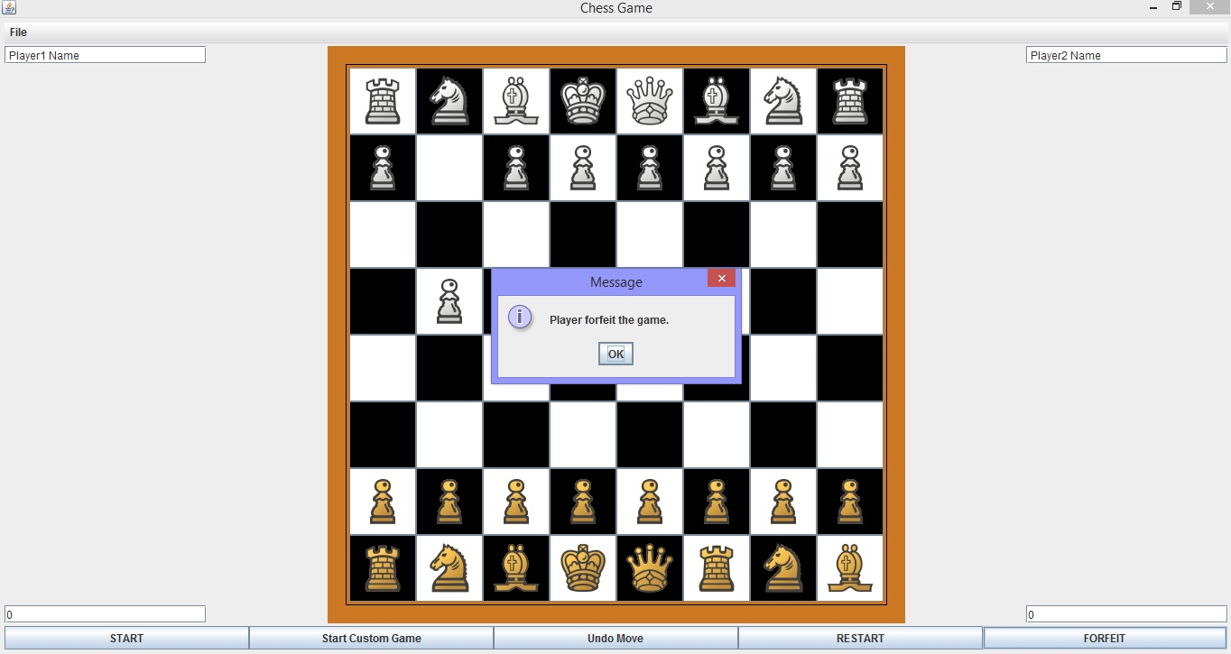

1. **Player can even request a restart. This has to be accepted by the other player.**

